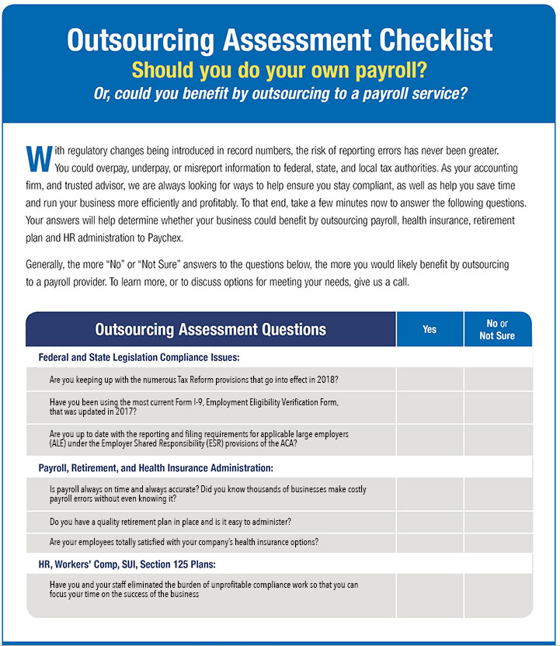

Intended for CPAs to send to their clients
Insert CPA name, phone, email, and other contact information here

